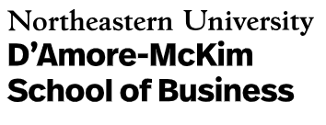
ADMISSIONS STAFF

Evelyn Tate
Director, Graduate Recruitment and Admissions
Phone: 617.373.3258
Email: e.tate@northeastern.edu

Linda Harding
Associate Director
Phone: 617.373.4765
Email: l.harding@northeastern.edu

Hannah Brower
Operations Assistant
Phone: 617.373.8320
Email: h.brower@northeastern.edu

Alexandra Munroe
Associate Director
Phone: 617.373.4733
Email: a.munroe@northeastern.edu

Dena Snyder
Admissions Manager
Phone: 617.373.8877
Email: de.snyder@northeastern.edu

Kellianne Frankel
Operations Assistant
Phone: 617.373.6310
Email: k.frankel@northeastern.edu

Helpful Contact
(617.373.XXXX)

Program and Student Services Team
Full-Time MBA: Lauren Fallon x6978
Part-Time MBA: Evelyn Gonzalez x5999
MS in Innovation: Carolyn Boviard x4808
Master of Science Programs: Sandra Foley x8885
Assistant Dean of Programs and Student Services: Gail Justino-Miller x4264

University Offices
Career Center: x3003
Book Store: x2286
Billing: x2270
Financial Aid: x3190
Cashier/Parking: x2366
NU Off-Campus Student Services: x8480
Student Customer Service: x2300
IT Help Desk: x4357

